EXP NO : 2 Data Splitting and cross-validation
Ex no : 2.1 Data Split

AIM : To split a dataset into training and testing sets using the train_test_split() function from the Scikit-learn library, with 80% of the data used for training and 20% used for testing

ALGORITHM :
- Start the program.
- Import the Pandas library and train_test_split from Scikit-learn.
- Load the dataset from the file data.csv.
- Select Hours_Studied, Attendance, and Assignments as input features.
- Select Result as the target variable.
- Split the dataset into training and testing sets using train_test_split() with test_size=0.2 and random_state=42.
- Display the training data.
- Display the testing data.
- Print the number of training samples and testing samples.
- Stop the program.
PROGRAM :

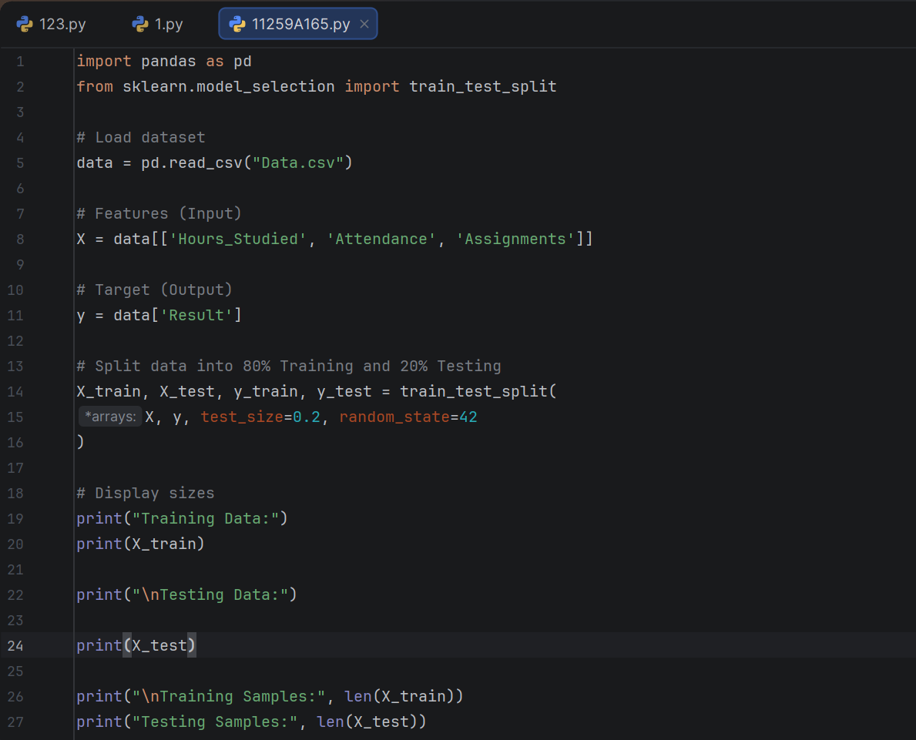

OUTPUT : 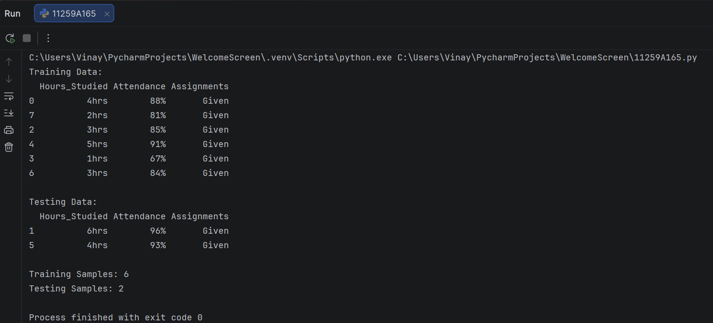

RESULT : Thus, the Python program was executed successfully to split the dataset into training and testing sets in an 80:20 ratio. The training data, testing data, and their respective sample counts were displayed.

Ex no : 2.2 Cross Validation

AIM : To implement a K-Nearest Neighbors (KNN) classification algorithm and evaluate its performance using 5-fold cross-validation in Python with the Scikit-learn library.

ALGORITHM :
- Start the program.
- Import the Pandas library and the required functions train_test_split, cross_val_score, and KNeighborsClassifier.
- Load the dataset from the file data.csv.
- Select Hours_Studied, Attendance, and Assignments as input features.
- Select Result as the target variable.
- Split the dataset into training and testing sets in an 80:20 ratio using train_test_split().
- Display the number of training and testing samples.
- Create a KNN classification model with n_neighbors=3.
- Perform 5-fold cross-validation using cross_val_score() with cv=5.
- Display the cross-validation scores for all five folds.
- Calculate and display the average accuracy using scores.mean().
- Stop the program.

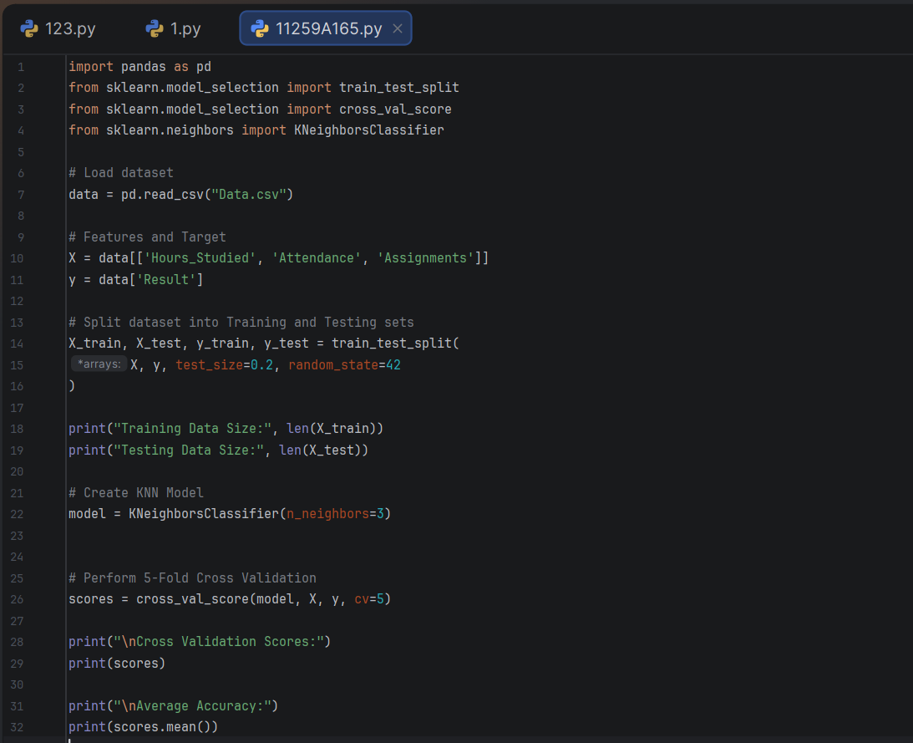
PROGRAM :

OUTPUT :
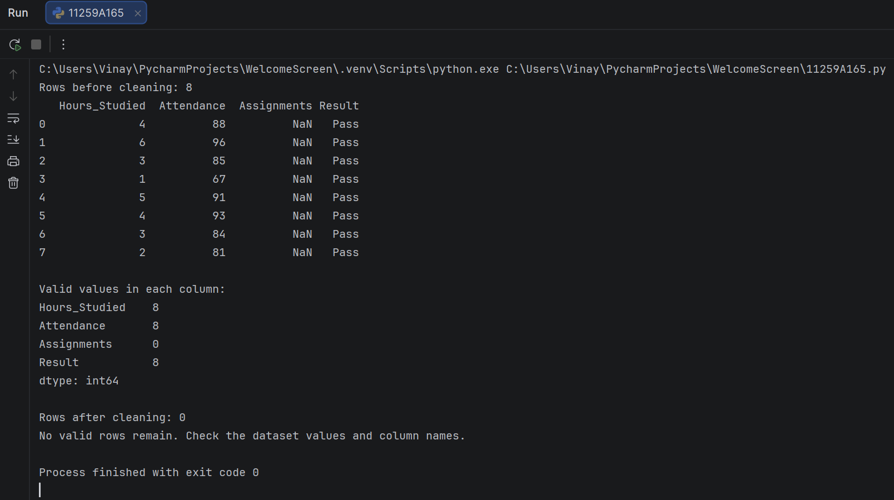

RESULT : Thus, the Python program was executed successfully to split the dataset into training and testing sets in an 80:20 ratio. The training data, testing data, and their respective sample counts were displayed.

